**Азбукин Даниил БСБО-10-21**

**Практическая №4**

App.py:

from flask import Flask  
  
app = Flask(__name__)  
  
  
@app.route('/')  
def hello_world():  
 return 'Hello, Docker!'  
  
  
if __name__ == '__main__':  
 app.run(host='0.0.0.0', port=8081)

Dockerfile:

FROM python:3.12-slim  
  
WORKDIR /app  
  
COPY requirements.txt requirements.txt  
RUN pip install -r requirements.txt  
  
COPY . .  
  
EXPOSE 8081  
  
CMD ["python", "app.py"]

Requirements.txt

Flask~=3.0.3

docker build -t flask_app_4 . – Создаем docker образ нашего приложения

docker run -p 8081:8081-d flask_app_4 – Запускаем контейнер с приложением

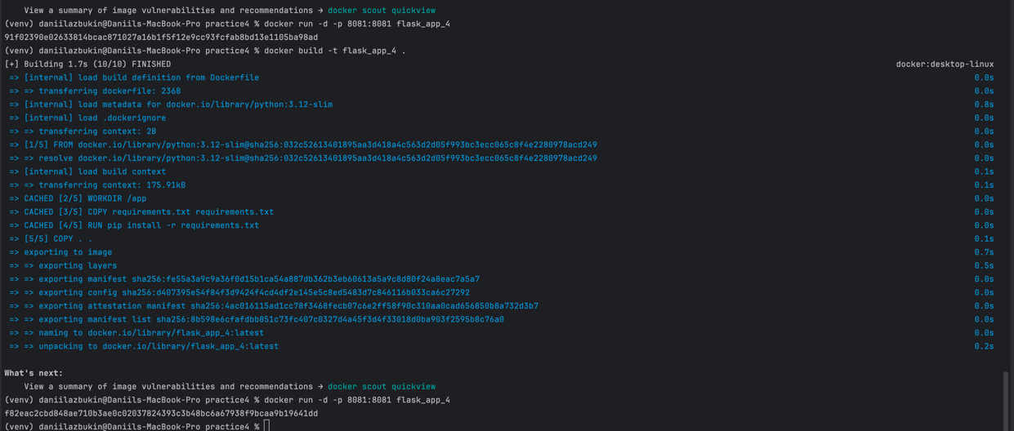

Чтобы уменьшить размер образа и контейнера, используем более легкую версию python:

Dockerfile:

FROM python:3.12-alpine  
  
WORKDIR /app  
  
COPY requirements.txt requirements.txt  
RUN pip install -r requirements.txt  
  
COPY . .  
  
EXPOSE 8081  
  
CMD ["python", "app.py"]

Создадим тесты и добавим их запуск в Dockerfile:

test_app.py:

from pytest import mark, fixture  
from requests import Session, Response  
  
  
class BaseSession(Session):  
 def __init__(self, **kwargs):  
 self.base_url = kwargs.pop('base_url')  
 super().__init__(**kwargs)  
  
 def request(self, method, url, **kwargs) -> Response:  
 response = super().request(method, url=f'{self.base_url}{url}', **kwargs)  
 return response  
  
  
@fixture  
def session():  
 return BaseSession(base_url='http://localhost:8081')  
  
  
def test_check_status_code(session):  
 response = session.get('/')  
 assert response.status_code == 200

Dockerfile:

FROM python:3.12-alpine  
  
WORKDIR /app  
COPY requirements.txt requirements.txt  
RUN pip install -r requirements.txt  
  
COPY . .  
  
EXPOSE 8081  
  
CMD ["sh", "-c", "python app.py & sleep 5 && pytest"]

Перебилдим и запустим проект и посмотрим логи контейнера:

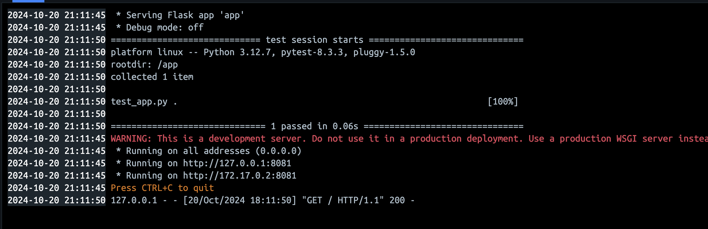

Создадим docker-compose.yaml с сервисами: наше приложение и postgres:

docker-compose.yaml:

version: '3'  
services:  
 web:  
 build: .  
 ports:  
 - "8081:8081"  
 depends_on:  
 - db  
 db:  
 image: postgres:13  
 environment:  
 POSTGRES_USER: user  
 POSTGRES_PASSWORD: password  
 POSTGRES_DB: flask_db  
 ports:  
 - "5432:5432"

docker-compose build – Билдим проект

docker-compose up – Поднимаем приложение с базой данных

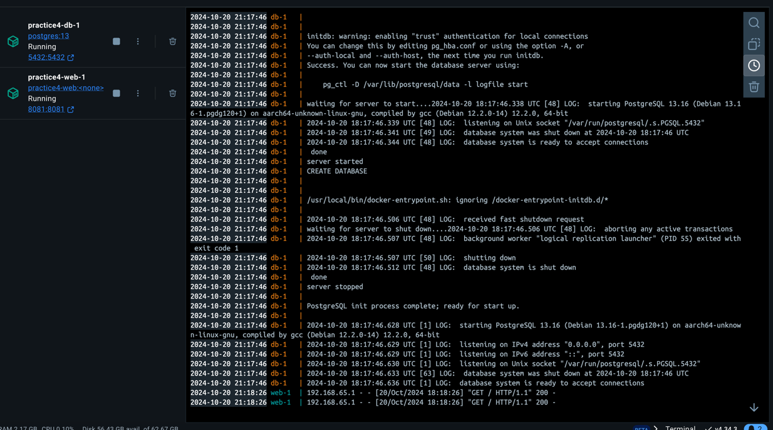

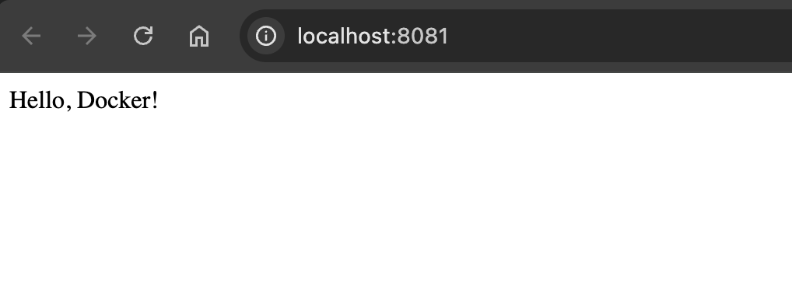

**Практическая №5**

1. Создание структуры из 2 приложений из Flask и Postgres

app.py – запуск приложения и прокидывание конфига

from config import Config  
from app import app, db  
  
  
with app.app_context():  
 db.create_all()  
  
  
if __name__ == '__main__':  
 app.run(host=Config.FLASK_APP_HOST,  
 port=Config.FLASK_APP_PORT,  
 debug=Config.FLASK_DEBUG)

config.py – сам конфиг приложения креды из env

import os  
from dotenv import load_dotenv  
  
BASE_DIR = os.path.abspath(os.path.dirname(__file__))  
load_dotenv(os.path.join(BASE_DIR, ".env"))  
  
  
class Config:  
  
 FLASK_APP = "app.py"  
 FLASK_APP_HOST = os.getenv("FLASK_APP_HOST")  
 FLASK_APP_PORT = os.getenv("FLASK_APP_PORT")  
 FLASK_DEBUG = os.getenv("FLASK_DEBUG")  
  
 SQLALCHEMY_DATABASE_URI = os.getenv("SQLALCHEMY_DATABASE_URI")  
 SQLALCHEMY_TRACK_MODIFICATIONS = os.getenv("SQLALCHEMY_TRACK_MODIFICATIONS")  
  
 CACHE_TYPE = 'redis'  
 CACHE_REDIS_HOST = os.getenv("REDIS_HOST")  
 CACHE_REDIS_PORT = os.getenv("REDIS_PORT")  
 CACHE_REDIS_DB = os.getenv("REDIS_DB")  
 CACHE_REDIS_URL = f"redis://{CACHE_REDIS_HOST}:{CACHE_REDIS_PORT}/{CACHE_REDIS_DB}"  
  
  
settings = Config

app.__init__.py – пакет для импорта базы данных и самого потока приложения

from flask import Flask  
from flask_sqlalchemy import SQLAlchemy  
from config import Config  
from flask_migrate import Migrate  
from flask_caching import Cache  
  
app = Flask(__name__)  
app.config.from_object(Config)  
  
cache = Cache(app)  
  
db = SQLAlchemy(app)  
migrate = Migrate(app, db)  
  
from app import routes, models, constants

app.routes.py – роуты приложения

from flask import request  
from app.models import User  
from app import app, db, cache  
from app.utils import internal_error_response, is_user_exist, make_user_id_cache_key  
from app.constants import USER_ALREADY_EXISTS, USER_NOT_FOUNDED  
  
  
@app.get('/users')  
def get_users():  
 *"""Get all users from database"""* users = User.query.all()  
 users_list = [user.to_dict() for user in users]  
 return users_list  
  
  
@app.route('/user/<int:user_id>')  
@cache.cached(timeout=300, make_cache_key=make_user_id_cache_key)  
def get_user(user_id):  
 *"""Gets user by id"""* user = User.query.get(user_id)  
  
 if not user:  
 return USER_NOT_FOUNDED, 404  
  
 return user.to_dict(), 200  
  
  
@app.post('/users')  
def create_user():  
 *"""Create new user in database"""* data = request.get_json()  
 username, email = data['username'], data['email']  
  
 if is_user_exist(email):  
 return USER_ALREADY_EXISTS, 404  
  
 try:  
 new_user = User(username=username, email=email)  
 db.session.add(new_user)  
 db.session.commit()  
 except Exception as err:  
 return internal_error_response(err)  
  
 return {'message': f'User with id = {new_user.id} created successfully'}  
  
  
@app.put('/users/<int:user_id>')  
def update_user(user_id):  
 *"""Update user in database"""* user = User.query.get(user_id)  
 data = request.get_json()  
  
 if not user:  
 return USER_NOT_FOUNDED, 404  
  
 try:  
 user.username = data.get('username', user.username)  
 user.email = data.get('email', user.email)  
 db.session.commit()  
 except Exception as err:  
 return internal_error_response(err)  
  
 return {'message': 'User updated successfully'}  
  
  
@app.route('/users/<int:user_id>', methods=['DELETE'])  
def delete_user(user_id):  
 *"""Delete user from database"""* user = User.query.get(user_id)  
  
 if not user:  
 return USER_NOT_FOUNDED, 404  
  
 try:  
 db.session.delete(user)  
 db.session.commit()  
 except Exception as err:  
 return internal_error_response(err)  
  
 return {'message': 'User deleted successfully'}  
  
  
@app.get('/clear_cache/<int:user_id>')  
def clear_user_cache(user_id):  
 *"""Clear cache for user with id"""* cache.delete(f'user_data::{user_id}')  
 return {'message': f'Cache for user {user_id} cleared'}

app.models.py – модели для базы данных

from app import db  
  
  
class User(db.Model):  
 id = db.Column(db.Integer, primary_key=True)  
 username = db.Column(db.String(80), unique=True, nullable=False)  
 email = db.Column(db.String(120), unique=True, nullable=False)  
  
 def __repr__(self):  
 return f'<User {self.username}>'  
  
 def to_dict(self):  
 return {  
 'id': self.id,  
 'username': self.username,  
 'email': self.email  
 }

app.utils.py – доп функции

from app.constants import ERROR_500_TEXT, USER_ALREADY_EXISTS  
from app import db  
from app.models import User  
from flask import request  
  
  
def make_user_id_cache_key(*args, **kwargs):  
 *"""User id cache key"""* user_id = kwargs['user_id']  
 return f'user_data::{user_id}'  
  
  
def internal_error_response(err):  
 *"""  
 Returns error response  
 :param err: Exception  
 :return: dict  
 """* return {  
 'message': ERROR_500_TEXT,  
 'error': str(err)  
 }, 500  
  
  
def is_user_exist(email):  
 *"""  
 Check if user with email exist in database  
 :param email:  
 :return:  
 """* user_with_email = User.query.filter_by(email=email).first()  
 return user_with_email is not None

.env – envшный конфиг

FLASK_APP_HOST=0.0.0.0  
FLASK_APP_PORT=8081  
FLASK_DEBUG=1  
  
SQLALCHEMY_DATABASE_URI=postgresql://postgres:secret@db:5432/flask_app  
SQLALCHEMY_TRACK_MODIFICATIONS=0  
  
REDIS_HOST=  
REDIS_PORT=  
REDIS_DB=0

requirements.txt

alembic==1.13.3  
blinker==1.8.2  
cachelib==0.9.0  
click==8.1.7  
Flask==3.0.3  
Flask-Caching==2.3.0  
Flask-Migrate==4.0.7  
Flask-SQLAlchemy==3.1.1  
itsdangerous==2.2.0  
Jinja2==3.1.4  
Mako==1.3.6  
MarkupSafe==3.0.2  
psycopg2-binary==2.9.10  
python-dotenv==1.0.1  
redis==5.2.0  
SQLAlchemy==2.0.36  
typing_extensions==4.12.2  
Werkzeug==3.0.4

Dockerfile – докерфайл для запуска приложения фласки

FROM python:3.12-slim  
  
WORKDIR /app  
  
COPY requirements.txt requirements.txt  
  
RUN pip install -r requirements.txt  
  
COPY . .  
  
EXPOSE 5000  
  
CMD ["python", "app.py"]

Docker-compose.yaml – композ файл для запуска bd и приложения в контейнерах

version: '3.7'  
services:  
  
 web:  
 build: .  
 ports:  
 - "8081:8081"  
 depends_on:  
 db:  
 condition: service_healthy  
 redis:  
 condition: service_healthy  
 environment:  
 - SQLALCHEMY_DATABASE_URI=postgresql://postgres:secret@db:5432/flask_app  
 - REDIS_HOST=redis  
  
 db:  
 image: postgres:13  
 environment:  
 POSTGRES_USER: postgres  
 POSTGRES_PASSWORD: secret  
 POSTGRES_DB: flask_app  
 ports:  
 - "5432:5432"  
 healthcheck:  
 test: ["CMD-SHELL", "pg_isready -U postgres"]  
 interval: 10s  
 timeout: 5s  
 retries: 5  
  
 redis:  
 image: redis:alpine  
 ports:  
 - "6379:6379"  
 healthcheck:  
 test: ["CMD", "redis-cli", "ping"]  
 interval: 10s  
 timeout: 5s  
 retries: 5

Билд приложения:

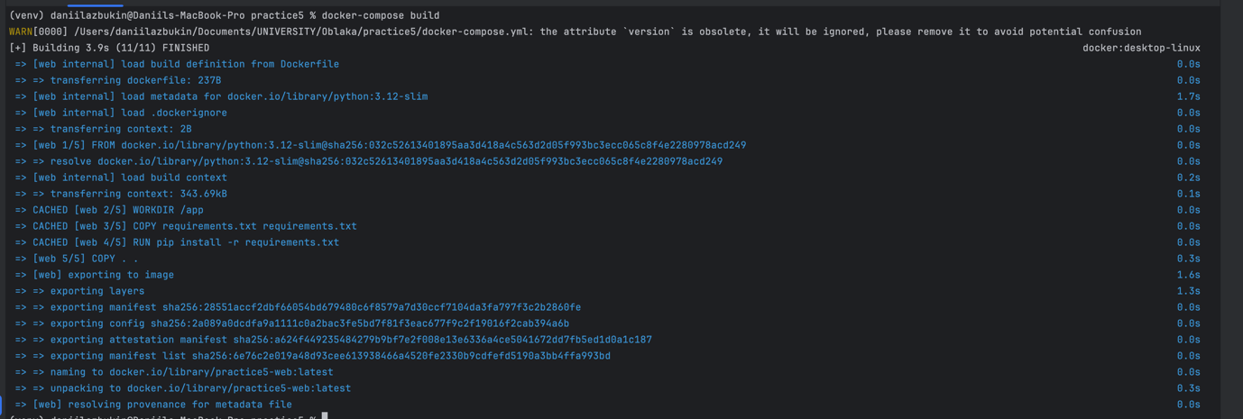

Запуск в композе:

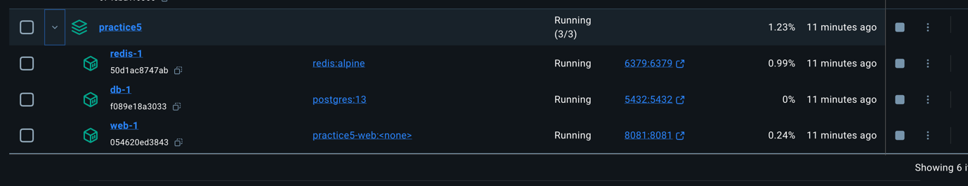

Миграции:

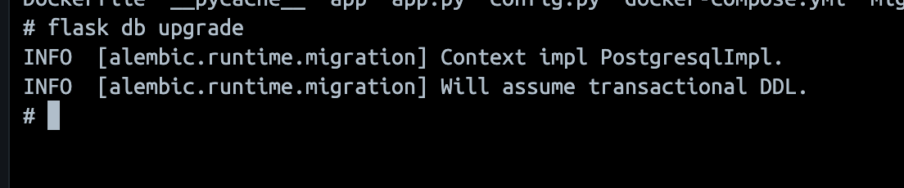

Создание пользователя:

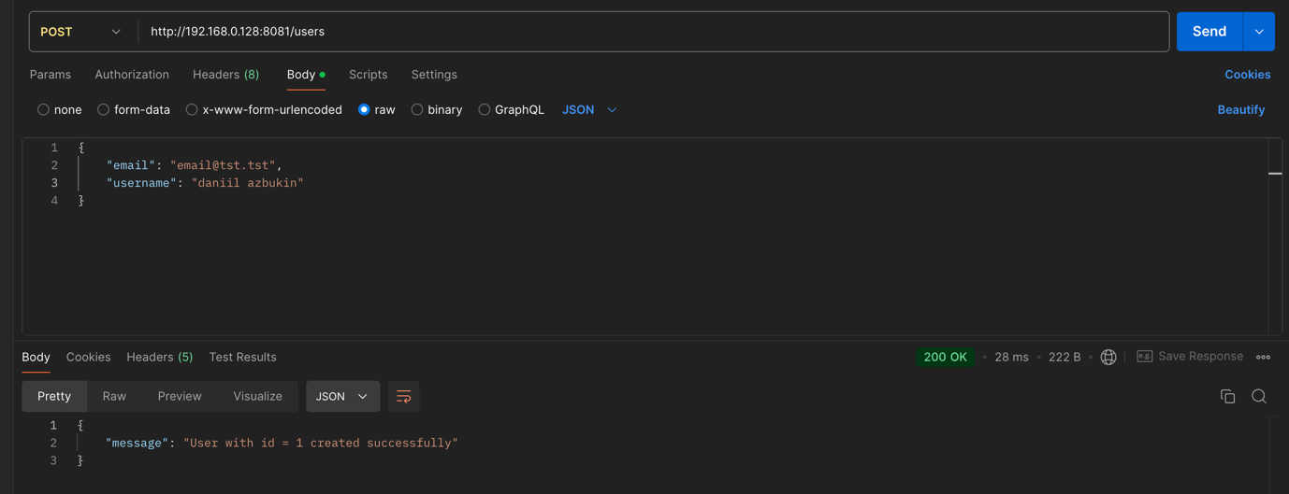

Получение пользователей:

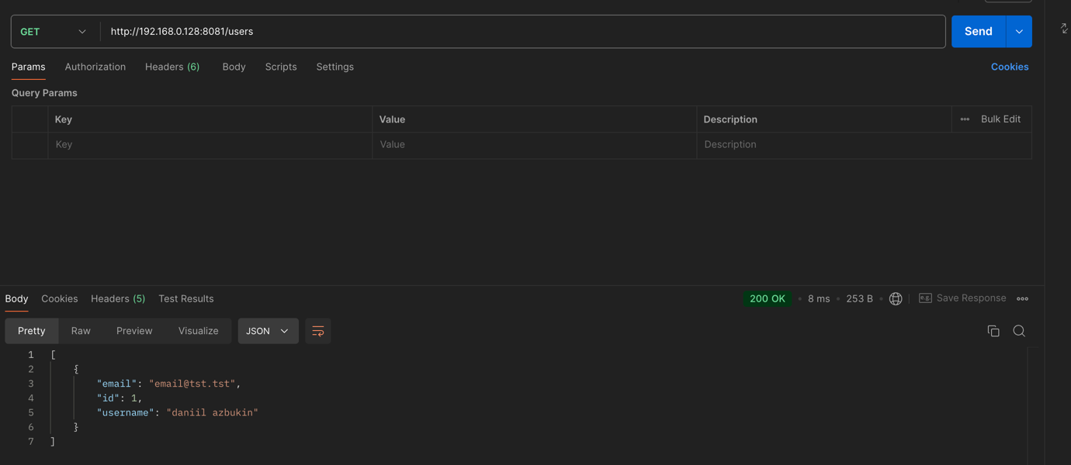

Изменение пользователей:

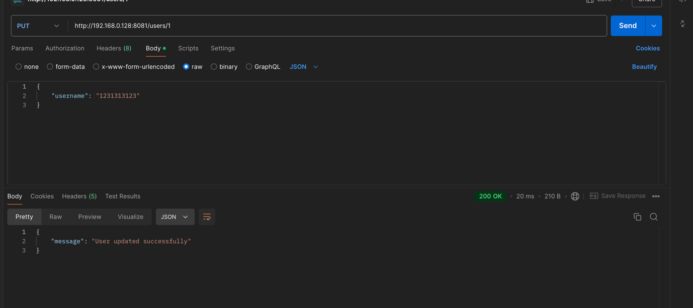

Получение пользователя по ID:

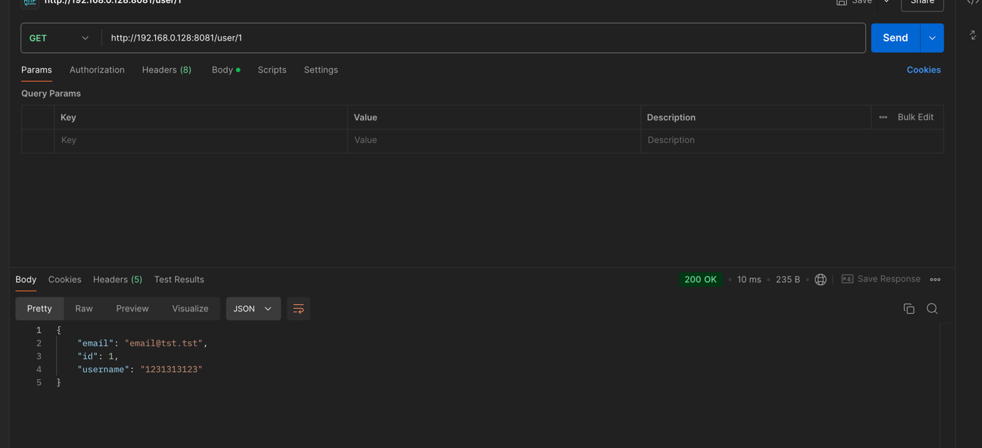

Очистка кеша:

1. Кешируем пользователя отправив запрос

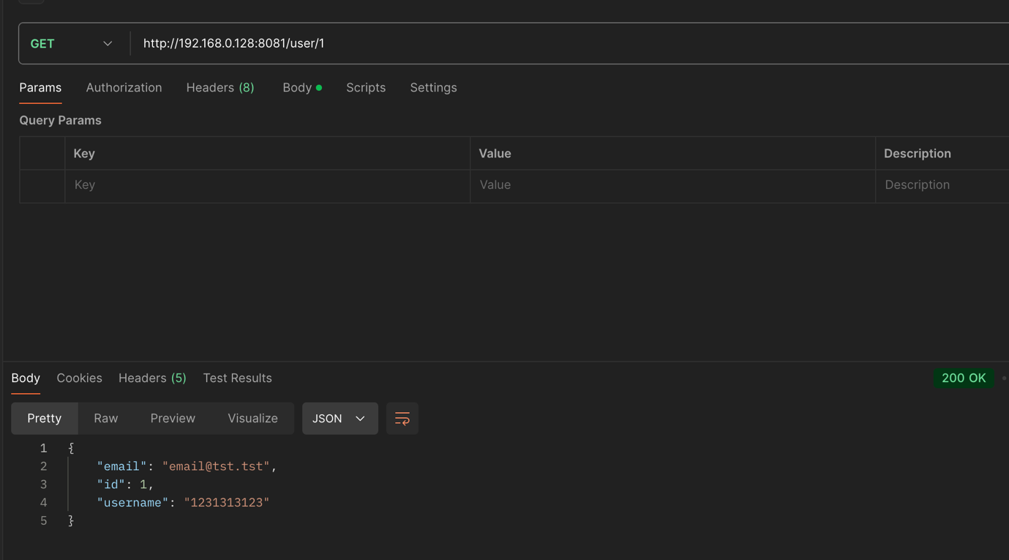

1. Меняем пользователю username

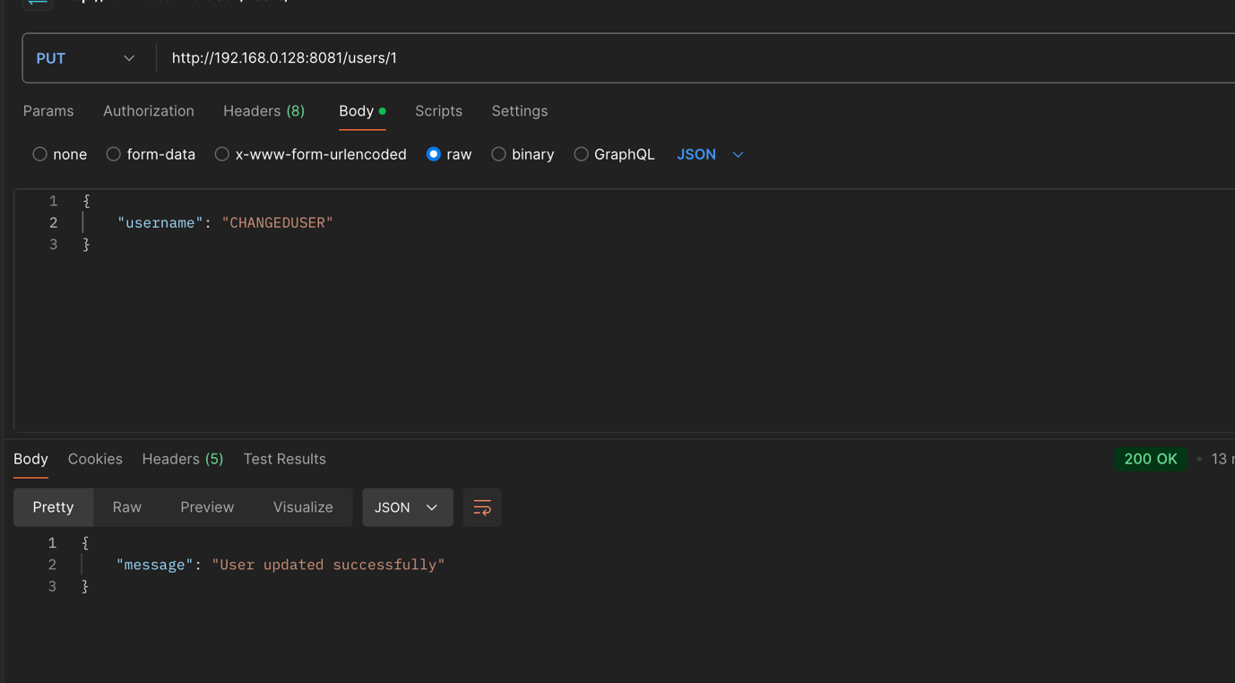

1. Проверка, что пользователь закеширован

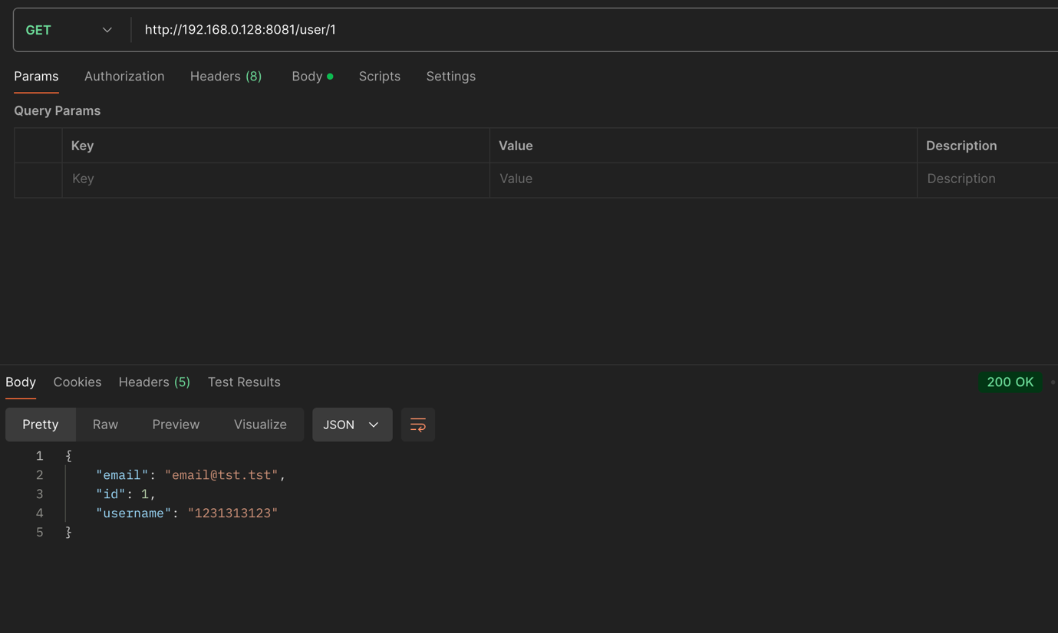

1. Чистим кеш для пользователя

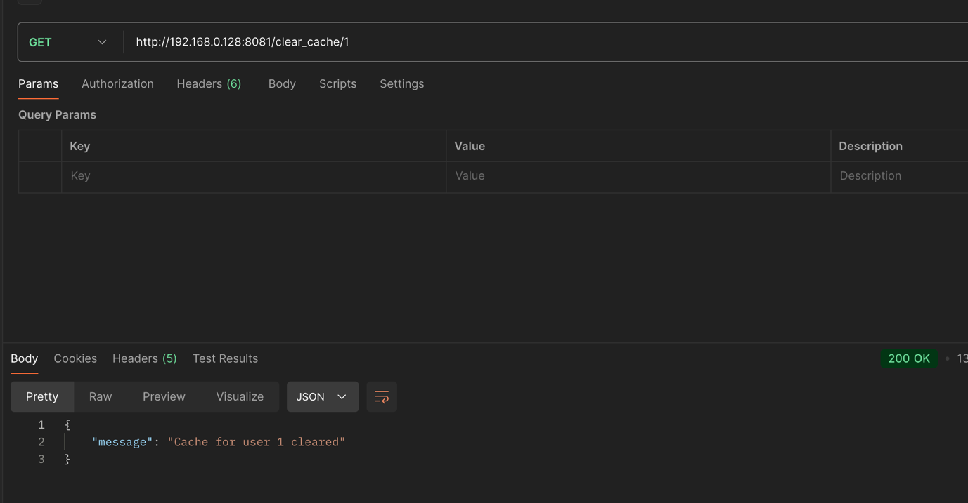

1. Проверяем что кеш почистился

